Laboratory 1: Calibration of a High-Volume Sampler
Laboratory
1

1.1 To the User of this Manual
This manual has been prepared to guide the students through a series of laboratory exercises developed to provide the students a hands-on experience related to atmospheric sampling issues and concepts discussed in the lecture portion of this course. The primary objective of these exercises is for the students to gain a practical understanding of common procedures necessary to sample and monitor ambient air. These exercises focus on the calibration of flow measuring devices and particulate matter sampling instruments.
The laboratory exercises are grouped into three main categories (i.e., sessions): the calibration of a high-volume sampler, flow measuring instrumentation, and calibration of a PM_{2.5} sampler. Each laboratory session has several experiments that are to be completed in a 4-6-hour lab session. Please take time to read each experiment before you attend the lab session (read for purpose and overall structure - not detail). Each of the three lab sessions begins with an introduction, a list of objectives, and a list of what should be included in your lab report. At the end of each experiment you will find duplicate copies of the appropriate data sheet. One copy is for your records and one is for your report to the instructor.
Appendix A of this manual provides the student a laboratory report format that should be followed in preparing their reports unless otherwise directed by the instructor. Graph paper is provided in Appendix B for the students’ use in plotting calibration curves. It will be necessary for these graphs to be included in the results section of the students’ laboratory reports.

Nomenclature
c concentration of SO₂ in test atmosphere
c₁ concentration of NO in standard NO cylinder
c₂ concentration of NO in test atmosphere
C.F. correction factor
I high-volume sampler’s indicated flow rate
k reference flow device calibration factor
MW molecular weight
P absolute pressure
P_{b} barometric pressure
p_{g} gauge pressure
P_{m} barometric pressure corrected for internal pressure of wet test meter
ppm parts per million
PR permeation rate
P_{std} standard pressure (760 mm Hg)
P_{v} saturation vapor pressure over water
Q flow rate
Q_{c} flow of air through permeation oven
Q_{d} flow of dilution zero air
Q_{m} measured flow rate
Q_{ReF} flow through reference flow device
Q_{s} flow rate from NO cylinder
Q_{std} flow rate corrected to standard conditions of 25°C and 760 mm Hg
Q_{total} total flow rate
Q_{s} flow rate from zero air cylinder
T temperature
T_{m} temperature of wet test meter water
T_{r} temperature of aspirator bottle
T_{std} standard temperature (25 °C)
TSP total suspended particulate matter
V_{a} volume of air passed through wet test meter corrected by correction factor
V_{c} volume of air passed through wet test meter corrected to meter conditions
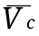 average volume of air passed through wet test meter corrected to meter conditions
V_{f} final volume reading
V_{i} initial volume reading
V_{m} measured volume
V_{mol} molar volume
V_{sr} volume of Class A volumetric flask
V_{std} volume of air corrected to standard conditions of 25°C and 760 mm Hg
W_{i} initial weight of hi-vol filter
W_{f} final weight of hi-vol filter
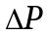 pressure drop
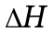 pressure drop across hi-vol flow rate transfer standard
θ time

1.2 Laboratory 1: Introduction
Accurate calibration of the hi-vol flow rate is necessary for meaningful total suspended particulate matter (TSP) measurements and in the determination of lead in ambient air. The standard against which hi-vol flows are referenced is a positive displacement volume meter, such as a Roots meter. Because hi-vols are located in the field and Roots meters are very heavy and hard to transport, a transfer flow rate standard, such as an orifice calibration unit, is used to calibrate hi-vols. First, a calibration curve is obtained for the orifice by comparing the pressure drop across the orifice to the volume measured by the Roots meter. The orifice is then used to calibrate the hi-vol’s flow rate measuring device, such as a recording transducer. Field audits on the flow calibration are performed with a Reference Flow device (ReF device).
Inconsistent flow rate is a major cause of hi-vol error. Several constant flow controllers have been developed and marketed in the past; however, the controller in wide use today employs a mass flow transducer. In this lab, you will get a chance to see how well flow is controlled by this method.
This laboratory will consist of the following three experiments:

Experiment 1: Reference Method Calibration of a High-Volume Sampler
Experiment 2: Reference Flow Device Audit
Experiment 3: Constant Flow High-Volume Sampler Check

Objectives
At the conclusion of this laboratory session, you will be able to:
- calibrate an orifice flow rate transfer standard with a Roots meter, making all necessary corrections for temperature and pressure;
- calibrate, according to the Reference Method, a hi-vol equipped with a recording pressure transducer;
- perform a field audit on the flow calibration of a hi-vol using a ReF device; and
- perform a check on the constant flow performance of a constant flow hi-vol.

1.3 Experiment 1: Reference Method Calibration of a High-Volume Sampler

Introduction
In this experiment you will investigate the calibration procedure for the hi-vol as described in Appendix B of 40 CFR 50, “Reference Method for the Determination of Suspended Particulate Matter in the Atmosphere (High-Volume Method).”
The procedure includes the calibration of an orifice flow rate transfer standard against a positive displacement volume meter, such as a Roots meter. After the orifice is calibrated, the hi-vol’s flow rate measuring device, such as a recording transducer, is calibrated against the orifice. First, we will perform the orifice calibration.
Duplicate data sheets are provided at the end of each experiment. One copy is for your records and the other one is to be turned in as a report.

Orifice Calibration Procedure
The orifice is usually calibrated in the laboratory. This orifice calibration is performed rather infrequently if the orifice is protected from damage. Calibrations are usually performed every year.
The experimental setup in Lab 1, Figure 1 has already been prepared for you. The following is a step-by-step procedure for the calibration of the orifice.
- Record the room temperature, T₁, in °C and K (K = 273+ °C).
- Record the barometric pressure, P₁, in mm Hg.
- Locate the setup shown in Lab 1, Figure la. NOTE: The set of five multihole resistance plates is used to change the flow through the orifice so that several points can be obtained for the orifice calibration curve.
- Check the oil level of the Roots meter prior to starting. There are three oil level indicators - one at the clear plastic end and two site glasses, one at each end of the measuring chamber.
- Check for leaks by clamping both manometer lines blocking the orifice with cellophane tape, turning on the hi-vol motor, and noting any change in the Roots meter’s reading.
- If the Roots meter’s reading changes, ask the instructor for assistance in eliminating the leak before proceeding.
- If the Roots meter’s reading remains constant, turn off the hi-vol motor, remove the cellophane tape, and unclamp both manometer lines.
- Install the 5-hole resistance plate between the orifice and the filter adapter.
- Turn manometer tubing connectors one turn counterclockwise. Make sure all connectors are open (Lab 1, Figure lb).
- Adjust both manometer midpoints by sliding their movable scales until the zero point corresponds with the meniscus. Gently shake or tap to remove any air bubbles and/or liquid remaining on tubing connectors. (If additional liquid is required for the water manometer, remove tubing connector and add distilled water which is dyed to improve readibility.) See Lab 1, Figure lb.
- Turn on the hi-vol motor and allow it to run for at least one minute to obtain a constant motor speed.
- Record both manometer readings - orifice water manometer (J-I) and Roots meter mercury manometer (∆P). NOTE: ∆P or ∆H is the sum of the difference from zero (0) of the two column heights. See Lab 1, Figure lc.
- Record the time, in minutes, required to pass a known volume of air through the Roots meter by using the Roots meter's digital volume dial and a stopwatch (plates 5 and 7 = 200 ft'; plates 10, 13, and 18 = 500 ft'). Use of these volumes aids in averaging out errors in reading the moving dial on the Roots meter and starting and stopping the stopwatch. The volume should be measured by using the non-compensated dial. The smallest dial division is 1 ft³.
- Turn off the hi-vol motor.
- Replace the 5-hole resistance plate with the 7-hole resistance plate.
- Repeat steps 5 through 7. NOTE: If resistance plates are not used to vary the flow rate through the orifice, this step may be eliminated.
- Repeat steps 11 through 14.
- Repeat steps 15 through 17 for the 10-hole, 15-hole, and 18-hole resistance plates.
- Correct the measured volumes to standard volumes using the following equation:
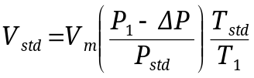
Where: V_{std} = standard volume, std m³
V_{m} = actual volume measured by the Roots meter
P₁ = barometric pressure during calibration, mm Hg
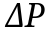 = differential pressure at inlet to volume meter, mm Hg
P_{std} = 760 mm Hg
T_{std} = 298 K
T₁ = ambient temperature during calibration, K
- Record the standard volumes.
- Calculate the standard flow rates using the following equation:
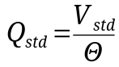
Where: Q_{std} = standard volumetric flow rate, std m³/min
 = elapsed time, min
- Record the standard flow rates to the nearest 0.01 std m³/min.
- Calculate and record 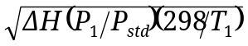 value for each standard flow rate.
- Plot each value (y-axis) versus its associated standard flow rate (x-axis) on arithmetic graph paper and draw a line of best fit between the individual plotted-points. This is the calibration curve for the orifice and should be included with your laboratory report.

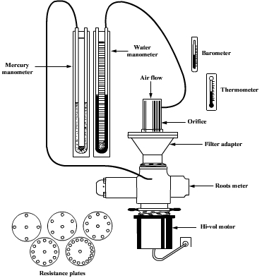
Lab 1, Figure 1a. Orifice calibration setup.
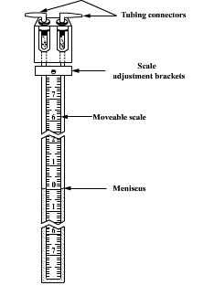
Lab 1, Figure lb. Manometer.

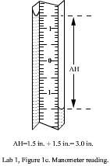
Lab 1, Figure lc. Manometer reading.

Laboratory 1, Experiment 1: Orifice Calibration Data Sheet

T₁ ____________°C ____________K Name____________________
P₁ ______________________ mm Hg Date____________________
Orifice no. _____________________ Group no.________________
Roots meter no. _________________

Resistance  plates  (no. of holes) |  | Air volume  measured by  Roots meter  V_{m} |  |  |  | Standard  volume  V_{std}  (std m³) |  | Time for air  volume to  pass through  Roots meter  θ  (min) |  | Roots meter  pressure  differential  (mm Hg) |  | Pressure  drop across  orifice  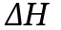  (in. H₂O) |  | z-axis  standard  flow rate  Q_{std}  (std m³/min) | y-axis  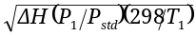value
 |  | (ft³) |  | (m³)
5 | 200 |  | 5.66
7 | 200 |  | 5.66
10 | 300 |  | 8.50
13 | 300 |  | 8.50
18 | 300 |  | 8.50

Factors: 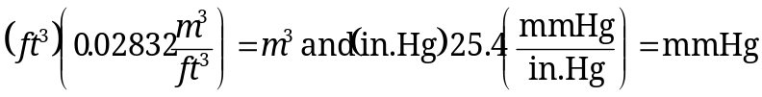
Calculation equations:

- 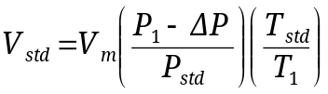

Where: T_{std} = 298 K
P_{std} = 760.0 mm Hg

- 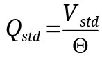

Page 1 of Lab Report

Laboratory 1, Experiment 1: Orifice Calibration Data Sheet

T₁ ____________°C ____________K Name ____________________
P₁ ______________________ mm Hg Date ____________________
Orifice no. _____________________ Group no.________________
Roots meter no. _________________

Resistance  plates  (no. of holes) |  | Air volume  measured by  Roots meter  V_{m} |  |  |  | Standard  volume  V_{std}  (std m³) |  | Time for air  volume to  pass through  Roots meter  θ  (min) |  | Roots meter  pressure  differential  (mm Hg) |  | Pressure  drop across  orifice  (in. H₂O) |  | z-axis  standard  flow rate  Q_{std}  (std m³/min) | y-axis  value
 |  | (ft³) |  | (m³)
5 | 200 |  | 5.66
7 | 200 |  | 5.66
10 | 300 |  | 8.50
13 | 300 |  | 8.50
18 | 300 |  | 8.50

Factors:
Calculation equations:

Where: T_{std} = 298 K
P_{std} = 760.0 mm Hg

- 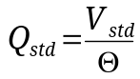

Page 1 of Lab Report

Transducer
A schematic of the transducer calibration setup is shown in Lab 1, Figure 2.
- Record ambient temperature of area where calibration is to take place, T₂, in °C and K (K = 273+ °C).
- Record barometric pressure of area where calibration is to take place, P₂, in mm Hg.
- Locate the setup shown in Lab 1, Figure 2.
- Turn on the hi-vol motor and allow it to run for at least five minutes to establish thermal equilibrium.
- Turn off the hi-vol motor.
- Install the 5-hole resistance plate between the orifice and the filter adapter. Be sure to tighten the orifice enough to eliminate any leaks. Also, check the gasket for cracks.
- After making sure that the transducer is indicating zero, turn on the hi-vol motor and allow it to run for at least two minutes to reestablish thermal equilibrium.
- Record the orifice manometer reading () and the transducer reading (I).
- Turn off the hi-vol motor.
- Repeat step 6 through 9 for the 7-hole, 10-hole, 13-hole, and 18-hole resistance plates.
- Calculate and record 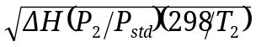value for each.
- Determine the standard flow rate (Q_{std}) associated with each value by referring to the orifice calibration curve (page 1A of your report).
- Record the standard flow rates.
- Calculate and record 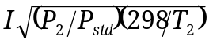 values for each transducer reading (I). NOTE: The formula for expressing I depends on the type of flow rate measuring device that is being calibrated and the method used for correcting sampled air volumes for ambient temperature and barometric pressure (Lab 1, Table 1).
- Plot each value (y-axis) versus its associated standard flow rate (x-axis) on arithmetic graph paper and draw a line of best fit between the individual plotted points. This is the calibration curve for the recording pressure transducer and should be included in your laboratory report.
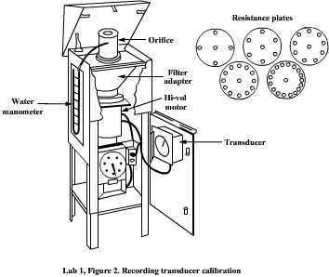
Lab 1, Figure 2. Recording transducer calibration.

Lab 1, Table 1. Formulas for expressing indicated flow rates of sampler flow rate measuring device calibration.
Type of sampler  flow rate measuring device | Expression
Type of sampler  flow rate measuring device | For actual pressure  and temperature  corrections | For incorporation of  geographic average barometric pressure (P_{a}) and seasonal  average temperature (T_{a})
Mass flowmeter | I | I
Orifice and pressure indicator | 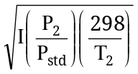 | 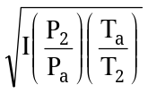
Rotameter, or orifice and pressure recorder having a square root scale* | 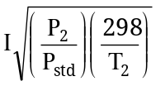 | 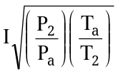
*This scale is recognizable by its nonuniform divisions and is the most commonly available for high-volume samplers.

Laboratory 1, Experiment 1: Transducer Calibration Data Sheet

T₂ __________°C __________ K Name __________________
P₂__________________ mm Hg Date __________________
Transducer no. _____________ Group no. ______________
Orifice no. _________________
Hi-vol motor no. ____________

Resistance plates  (no. of holes) | Manometer reading  (in. H₂O) | Transducer reading | 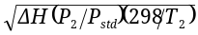  value | x-axis  Q_{std} from orifice calibration curve  (std m³/min) | y-axis  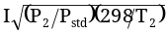  value
5
7
10
13
18
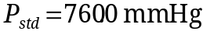

Page 2 of Lab Report

Laboratory 1, Experiment 1: Transducer Calibration Data Sheet

T₂ __________°C __________ K Name __________________
P₂__________________ mm Hg Date __________________
Transducer no. _____________ Group no. ______________
Orifice no. _________________
Hi-vol motor no. ____________

Resistance plates  (no. of holes) | Manometer reading  (in. H₂O) | Transducer reading | value | x-axis  Q_{std} from orifice calibration curve  (std m³/min) | y-axis  value
5
7
10
13
18

Page 2 of Lab Report

1.4 Experiment 2: Reference Flow Device Audit

Introduction
To ensure the quality of data reported from high-volume sampler networks, an accurate, quick, and easy audit technique is needed.
A device has been developed by the National Bureau of Standards (NBS), the predecessor to the National Institute of Standards and Technology (NIST) (under contract to the Environmental Monitoring Systems Laboratory of EPA) to provide a quick, easy, and accurate technique for flow calibration audits. The device developed (Lab 1, Figure 3) is a Reference Flow device, called a ReF device.
The ReF device is a modified orifice designed for ease of placement onto a high-volume sampler without disassembling the sampling unit (Lab 1, Figure 4).
During use, the ReF device is mounted on the sampler, replacing the filter gasket and faceplate. The top is opened and the first in a series of resistance plates is placed in the recessed area (Lab 1, Figure 5). With the top closed and the motor turned on, a pressure drop is read from the manometer, along with a flow reading taken from the sampler flow measuring device. This procedure is followed until each resistance plate has been used.
Measurement of the ambient temperature (T, K), barometric pressure (P, mm Hg), and pressure drop across the orifice (, in. H₂O), and knowledge of the ReF constant (k) allow the calculation of flow (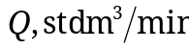) for a given resistance plate using the following equation:
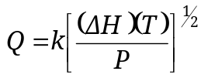
The k factor is experimentally determined for each ReF device using an accurate flow measurement device. This factor combines a correction factor for the particular characteristics of the device being calibrated and correction for the units of measurement to allow the answer to be expressed in std m³/min.
High-volume flow calibration can be checked by calculation of the % error between the flow as determined by the ReF device and the flow as determined during the hi-vol sampler calibration for a given resistance plate. The latter data are obtained from Experiment 1.

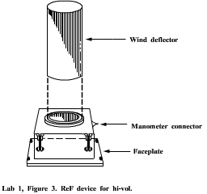
Lab 1, Figure 3. ReF device for hi-vol.
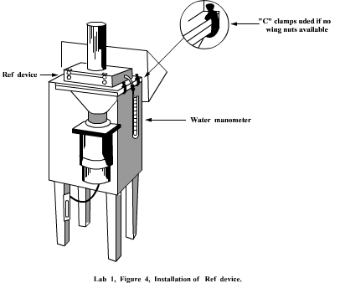
Lab 1, Figure 4. Installation of ReF device.

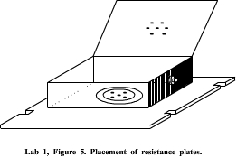
Lab 1, Figure 5. Placement of resistance plates.

Audit Procedure

Installation of ReF Device
- Remove faceplate and filter from hi-vol filter adapter.
- Install assembled ReF device on filter adapter of the sampler and fasten securely (Lab 1, Figure 4). NOTE: On filter adapter assemblies not having wing nuts, “C” clamps must be used to secure the ReF device (Lab 1, Figure 4 insert).
- Attach wind deflector to ReF device by inserting deflector into orifice retaining ring. Do not modify or change ReF in any manner to fit a particular sampler. ReF should never be stored or transported resting on bottom gasket.
- Mount water manometer in a vertical position (Lab 1, Figure 4).
- Turn the two manometer tubing connectors one turn counterclockwise. Make sure both connectors are open.
- Attach one manometer connection to ReF device pressure tap using tubing. Leave the other connector open to the atmosphere.
- Adjust manometer midpoint by sliding movable scale until zero point corresponds with the water meniscus. Gently shake or tap to remove any air bubbles and/or liquid remaining on tubing connectors. (If additional liquid is required, remove tubing connector and add distilled water dyed to improve readability.)

Operation of ReF Device
- Install a 5-hole resistance plate in ReF device by opening the lid and placing a resistance plate in machined opening (Lab 1, Figure 5). Close and fasten lid securely.
- Turn on high-volume sampler motor and let run five minutes.
- Record the atmospheric temperature, T, in °C and K (K = 273 + °C) and barometric pressure, P, in mm Hg.
- Record the following test data:
  - the observed difference in pressure (in inches of water) as indicated by the U-tube manometer. NOTE: is the sum of the difference from zero of the two water column heights.

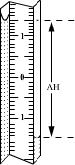
Lab 1, Figure 6. determination.
  - the transducer reading (I).
- At one-minute intervals, record four additional observations of and transducer reading (I). This helps eliminate the variations in motor performance.
- Turn off sampler. Open ReF lid and replace the 5-hole resistance plate with a 7-hole plate. Close lid and fasten securely. Turn on sampler.
- Repeat steps 4 through 6 for a 10-hole, 13-hole, and 18-hole resistance plate.
- Average the five observations for each resistance plate and record the averages on the data sheet. Calculate the flow rate through the ReF device (Q_{ReF}). Ask the instructor for k value. Remember T must be in K.

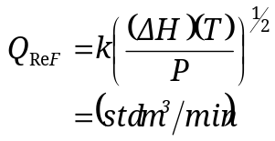

Where: k = calibration factor
= pressure drop across ReF, in. H₂O
T = ambient temperature, K
P = barometric pressure, mm Hg
- Average the five transducer readings (I) for each resistance plate.
- Record the average transducer readings.
- Calculate and record 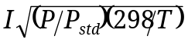value for each average transducer reading.
- Determine the standard flow rate (Q_{std}) associated with each value by referring to the transducer calibration curve as determined in Exercise 1.
- Record the standard flow rates.
- Calculate the % error of the transducer calibration for each flow rate that passed through the ReF device (Q_{ReF}) using the following equation:

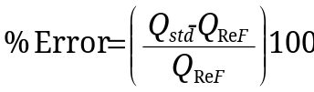

Laboratory 1, Experiment 2: Audit Data Sheet

Hi-vol motor no._______________ Name __________________
Transducer no._______________ Date __________________
T ____________ °C ___________K Group no._______________
P _____________________ mm Hg
ReF no.________k value _______

Resistance plate  no. | 5 |  | 7 |  | 10 |  | 13 |  | 18
Resistance plate  no. | (in. H₂O) | I | (in. H₂O) | I | (in. H₂O) | I | (in. H₂O) | I | (in. H₂O) | I
Reading no. 1
Reading no. 2
Reading no. 3
Reading no. 4
Reading no. 5
Average reading

= pressure drop of ReF device
I = indicated flow rate of transducer
Q_{std} = flow from calibration curve for transducer
Q_{ReF} = flow measured by ReF device
P_{std} = 760.0 mm Hg

Plate no. | Average I | 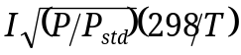 | 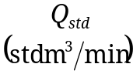 | Average  (in. H₂O) | 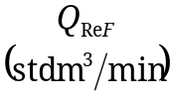 | % Error

Calculation equations:
- 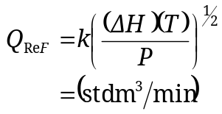
- 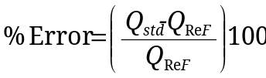

Page 3 of Lab Report

Laboratory 1, Experiment 2: Audit Data Sheet

Hi-vol motor no._______________ Name __________________
Transducer no._______________ Date __________________
T ____________ °C ___________K Group no._______________
P _____________________ mm Hg
ReF no.________k value _______

Resistance plate  no. | 5 |  | 7 |  | 10 |  | 13 |  | 18
Resistance plate  no. | (in. H₂O) | I | (in. H₂O) | I | (in. H₂O) | I | (in. H₂O) | I | (in. H₂O) | I
Reading no. 1
Reading no. 2
Reading no. 3
Reading no. 4
Reading no. 5
Average reading

= pressure drop of ReF device
I = indicated flow rate of transducer
Q_{std} = flow from calibration curve for transducer
Q_{ReF} = flow measured by ReF device
P_{std} = 760.0 mm Hg

Plate no. | Average I |  | 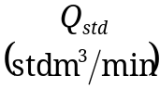 | Average  (in. H₂O) | 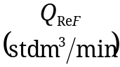 | % Error

Calculation equations:
- 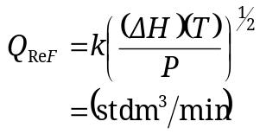

Page 3 of Lab Report

1.5 Experiment 3: Constant Flow High-Volume Sampler Check

Introduction
Variable flow rates in hi-vol sampling can cause signification errors. The reduction in flow errors can be accomplished through the use of a constant flow hi-vol, which compensates for increased pressure drop as the filter accumulates particles. The flow controller most commonly used today employs a mass flow probe. Because calibration of this constant flow hi-vol is very similar to the normal hi-vol calibration, a check on the operational characteristics will be of more value than a calibration. Specifically, you will investigate the range in which the constant flow hi-vol is capable of maintaining constant flow.

Procedure
- Record ambient temperature, T, in °C and K (K = 273 + °C) and barometric pressure, P, in mm Hg.
- Place the constant flow sampling head (normal sampling head with mass flow probe mounted in throat) onto the hi-vol motor (Lab 1, Figure 7). Be sure to tighten the head sufficiently to eliminate leaks. Also, check the gasket for cracks.
- Install the calibration orifice.
  - Remove the faceplate from the hi-vol filter holder.
  - Install calibration orifice on filter adapter assembly of the sampler with one clean filter in place and fasten securely (Lab 1, Figures 8 and 9).
  - Mount water manometer in a vertical position.
  - Using tubing, attach one manometer connector to the pressure tap of the calibration orifice. Leave the other connector open to the atmosphere.
  - Adjust the manometer midpoint by sliding the movable scale until the zero point corresponds with the water meniscus. Gently shake or tap to remove any air bubbles and/or liquid remaining on tubing connectors. (If additional liquid is required, remove tubing connector and add distilled water dyed to improve readability.)
- Turn on hi-vol motor and let run for five minutes. Make sure mass flow probe is plugged in and turned on.
- Record the pressure differential indicated, , in inches of water. Be sure stable has been established.
- Turn off sampler. Remove the calibration orifice and install another clean filter (now two filters are mounted) and fasten securely. Turn on sampler and record .
- Repeat step 5 using three and then four filters.
- Turn off sampler.
- Calculate and record 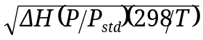value for each .
- Determine the standard flow rate (Q_{std}) associated with each value by referring to the orifice calibration curve as determined in Exercise 1.
- Record the standard flow rates.

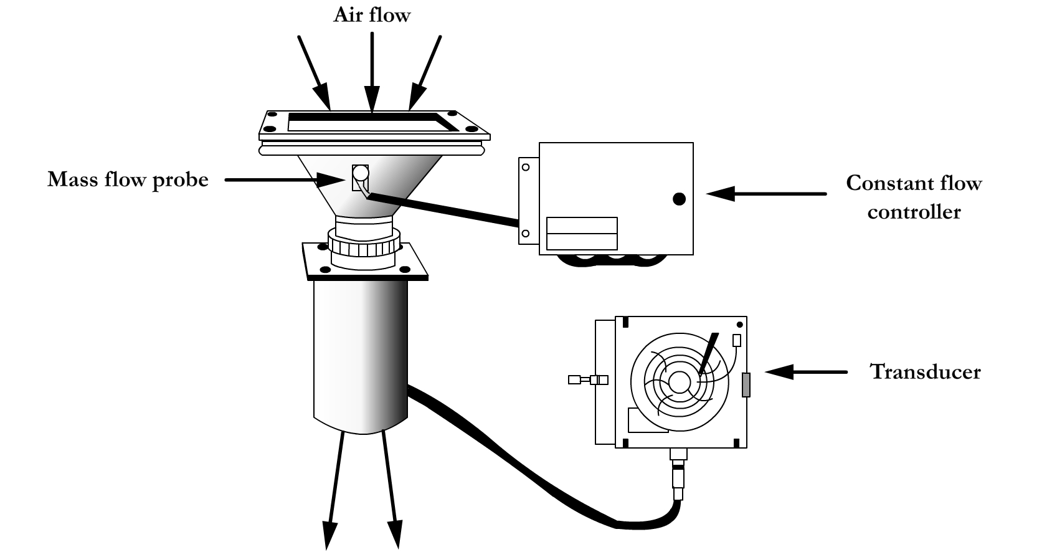
Lab 1, Figure 7. Hi-vol with constant flow controller.

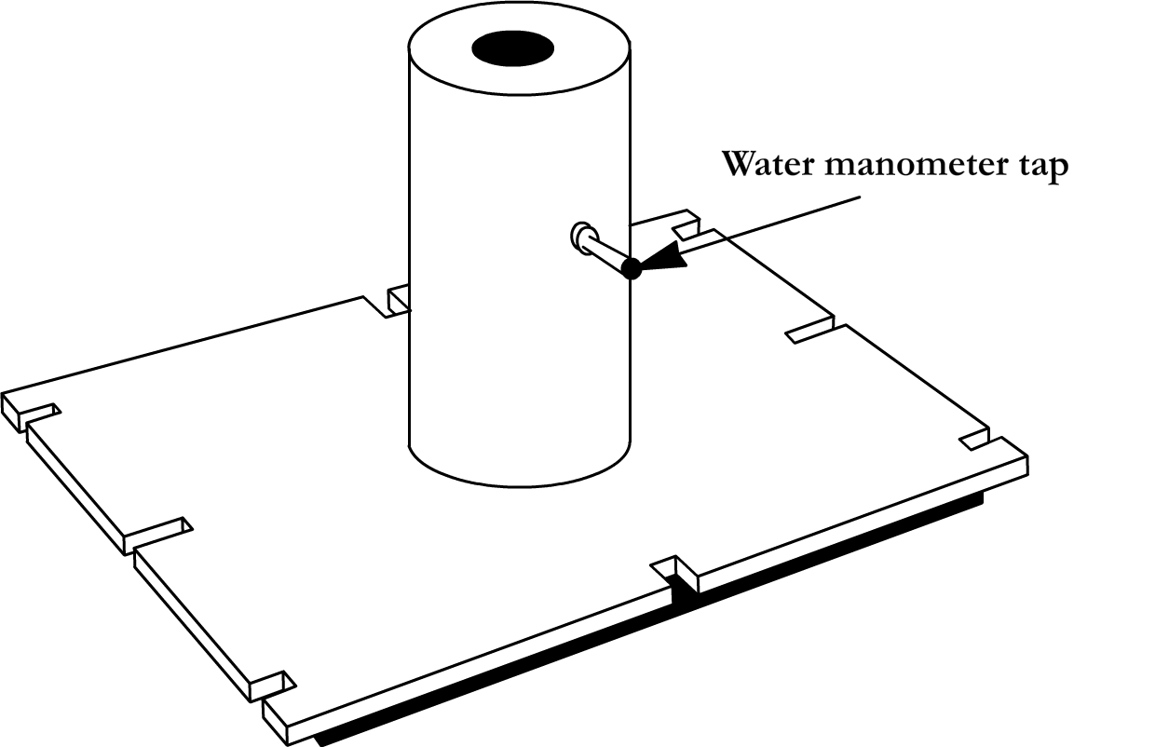
Lab 1, Figure 8. Calibration orifice.

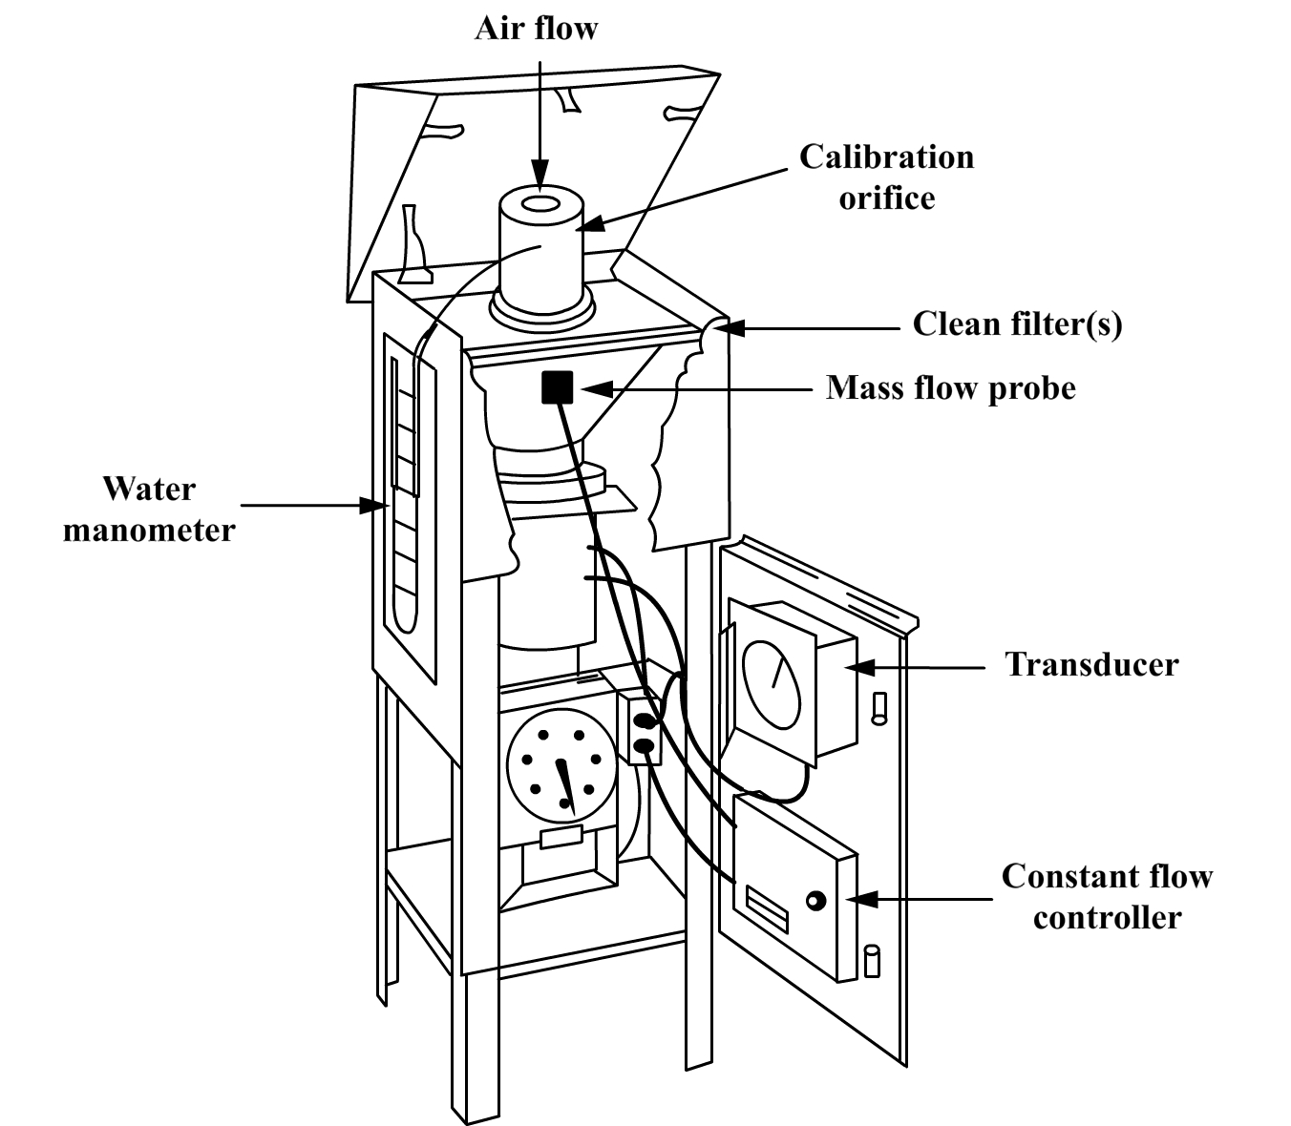
Lab 1, Figure 9. Hi-vol with constant flow controller and calibration orifice.

Laboratory 1, Experiment 3: Constant Flow High-Volume Sampler Check Data Sheet

T ____________ °C ____________ K Name__________________
P ________________________ mm Hg Date__________________
Flow controller no.________________ Group no._______________
Orifice no.______________________

Number of clean filters | (in. H₂O) | 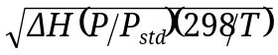  value | Q_{std}  (std m³/min)
1
2
3
4

P_{std} = 760.0 mm Hg

Page 4 of Lab Report

Laboratory 1, Experiment 3: Constant Flow High-Volume Sampler Check Data Sheet

T ____________ °C ____________ K Name__________________
P ________________________ mm Hg Date__________________
Flow controller no.________________ Group no._______________
Orifice no.______________________

Number of clean filters | (in. H₂O) | value | Q_{std}  (std m³/min)
1
2
3
4

P_{std} = 760.0 mm Hg

Page 4 of Lab Report

1.6 Problem Set: Laboratory 1

Example
Determine the total suspended particulate matter concentration (µg/std m³) obtained using a high-volume sampler under the following conditions:

Sampling data:
Weight of filter after sampling (W_{i}): 4.6437 g
Weight of filter before sampling (W_{f}): 4.5288 g
Initial flow rate indication: 55.0
Final flow rate indication: 53.0
Sampling interval: 1440.0 min
Average ambient temperature during sampling: 20.0°C
Average barometric pressure during sampling: 750 mm Hg
Type of flow rate measuring device used: Orifice and pressure recorder having a square root scale
Method of correcting sampled air volume for
ambient temperature and barometric pressure: Actual temperature and pressure are used for each sample

Calibration data for orifice-type flow rate transfer standard that was used to calibrate the high-volume sampler’s flow rate measuring device:

Problem Set 1, Table 1. Flow rate transfer standard calibration data.
Run | Air volume measured  by standard  volume meter  V_{m} (m³) | Time for air volume to pass through  standard volume meter t (min) | Pressure drop at  inlet of  standard volume meter  (mm Hg) | Pressure drop  across orifice  flow rate transfer standard  (in. H₂O)
1 | 5.66 | 5.553 | 93 | 2.95
2 | 5.66 | 4.463 | 80 | 4.70
3 | 8.50 | 5.515 | 66 | 7.20
4 | 8.50 | 4.925 | 55 | 9.50
5 | 8.50 | 4.488 | 46 | 11.70
Ambient temperature during calibration (T₁): 24.0°C.
Barometric pressure during calibration (P₁): 762 mm Hg.

Calibration data for high-volume sampler’s flow rate measuring device:
Problem Set 1, Table 2. Flow rate measuring device calibration data.

Run | Pressure drop across  orifice flow rate  transfer standard  (in. H₂O) | Sampler’s flow rate indication I  (arbitrary units)
1 | 2.85 | 34.0
2 | 4.40 | 42.0
3 | 6.25 | 51.0
4 | 7.70 | 57.0
5 | 9.40 | 62.0
Ambient temperature during calibration (T_{i}): 10.0°C.
Barometric pressure during calibration (P_{t}): 770 mm Hg.

Solution:
- The calibration curve for the transfer flow rate standard must be determined:
- Air volumes measured by the standard volume meter must be corrected to standard volumes (V_{std}) using the following equation:

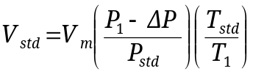

Example calculation for first volume measured (Table 1):

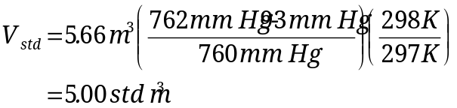

Calculated standard volumes:

Run | V_{m} (m³) | V_{std} (m³)
2 | 5.66 | 5.10
3 | 8.50 | 7.81
4 | 8.50 | 7.93
5 | 8.50 | 8.03
- Standard flow rates can now be calculated using the five standard air volumes and the following equation:
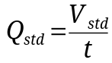

Example calculation using first standard air volume:

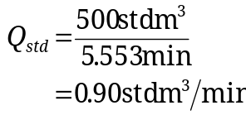
Calculated standard flow rates:

Run | V_{std} | Q_{std}
2 | 5.10 | 1.14
3 | 7.81 | 1.42
4 | 7.93 | 1.61
5 | 8.03 | 1.79

- Next, 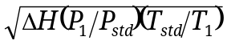is calculated for the 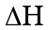associated with each standard flow rate (Table 1).

Example calculation using first standard flow rate having an associated of 2.95:

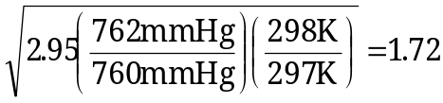

Calculated:

Run |  | 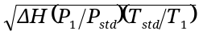
2 | 4.70 | 2.17
3 | 7.20 | 2.69
4 | 9.50 | 3.09
5 | 11.70 | 3.43
- The calibration curve can now be determined by plotting each 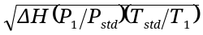 value against its associated standard flow rate and drawing a line of best fit between the individual plotted points (Figure 1) or calculating the slope (m) and y-intercept (b) of the curve by using linear least-squares regression analysis using the following equations:

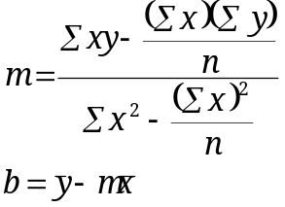
Where: n = number of x,y pairs
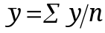
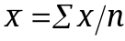
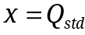
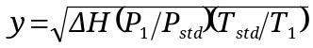
Problem Set 1, Table 3. x,y pairs for flow rate transfer standard calibration curve.

x (std m³/min) | 0.90 | 1.14 | 1.42 | 1.61 | 1.79
y | 1.72 | 2.17 | 2.69 | 3.09 | 3.43

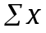 | 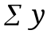 | 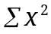 | 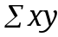
0.90 | 1.72 | (0.90)² = 0.81 | (0.90)(1.72)=1.55
1.14 | 2.17 | (1.14)²= 1.30 | (1.14)(2.17)=2.47
1.42 | 2.69 | (1.42)² = 2.02 | (1.42)(2.69)=3.82
1.61 | 3.09 | (1.61)²= 2.59 | (1.6.1)(3.09)=4.97
1.79 | 3.43 | (1.79)²= 3.20 | (1.79)(3.43)=6.14
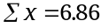 | 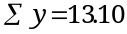 | 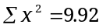 | 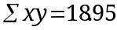

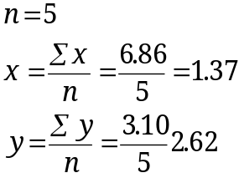
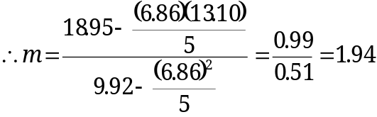
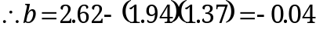

Equation of calibration curve:

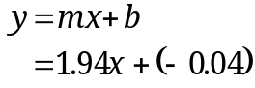

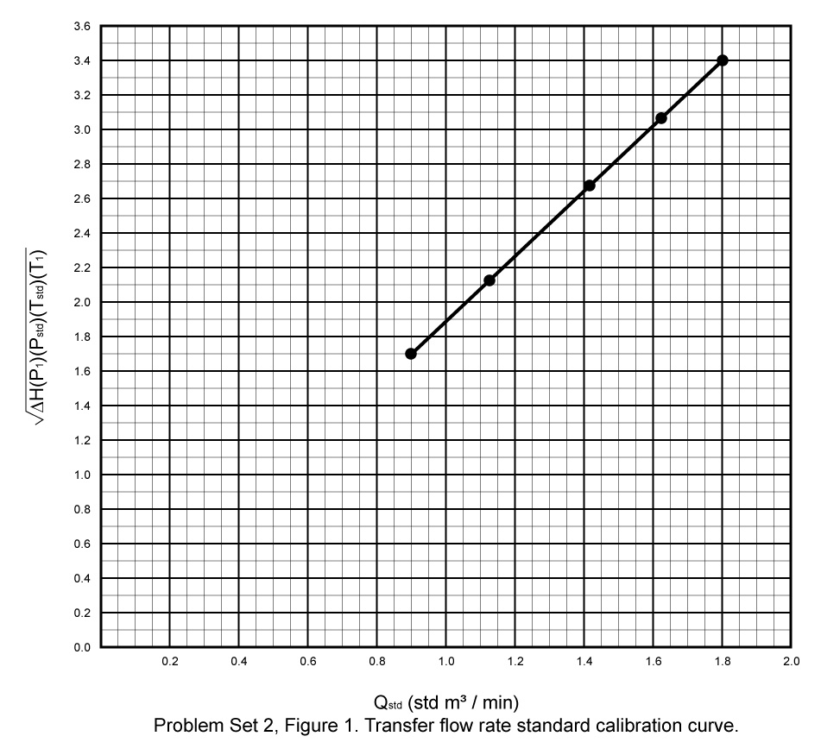
Problem Set 1, Figure 1. Flow rate measuring device calibration curve.
- The calibration curve for the sampler’s flow rate measuring device must be determined:
  - 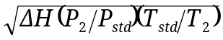values must be calculated for each that was measured during the calibration of the sampler’s flow rate measuring device (Table 2).

Example calculation using first of Table 2:

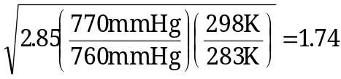

Calculated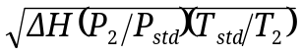:

Run
2 | 4.40 | 2.17
3 | 6.25 | 2.58
4 | 7.70 | 2.87
5 | 9.40 | 3.17

  - The calculated 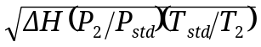 values can now be used to determine their associated flow rates at standard conditions by either referring to a graph of the transfer flow rate standard’s calibration curve (Figure 1) or by calculating the standard flow rates using the linear least-squares regression equation of the transfer flow rate standard's calibration curve:
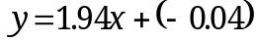

Where: 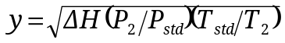
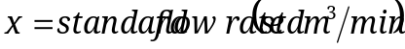

Example calculation using the first value (1.74):

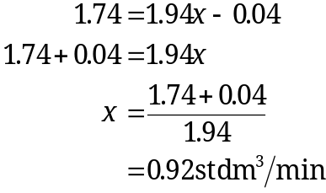

Associated standard flow rates:

Run | 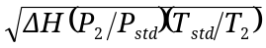 | x
2 | 2.17 | 1.14
3 | 2.58 | 1.35
4 | 2.87 | 1.50
5 | 3.17 | 1.65

  - Next, the sampler’s flow rate indications (I) during calibration (Table 2) must be expressed with regard to the type of flow rate measuring device used and the method of correcting sampled air volumes for ambient temperature and barometric pressure using the appropriate formula from Table 4.

Problem Set 1, Table 4. Formulas for expressing indicated flow rates of sampler flow rate measuring device calibration.
 | Expression
Type of sampler  flow rate measuring  device | For actual pressure  and temperature  correction | For incorporation of geographic average barometric pressure (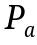) and seasonal average temperature (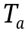)
Mass flowmeter | I | I
Orifice and pressure  indicator | 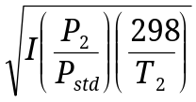 | 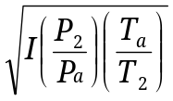
Rotameter, or orifice and pressure recorder having square root scale* | 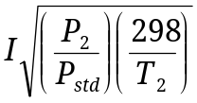 | 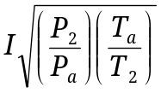
*This scale is recognizable by its nonuniform divisions and is the most commonly available for high-volume samplers.

Since the sampler’s flow rate measuring device is an orifice and pressure recorder having a square root scale and actual temperature and pressure are used to correct sampled air volumes, the sampler’s flow rate indications are expressed using 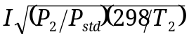.

Example calculation using the first (Table 2):

Calculated :

Run |  | 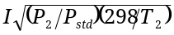
2 | 42.0 | 43.4
3 | 51.0 | 52.7
4 | 57.0 | 58.9
5 | 62.0 | 64.0

  - The calibration curve for the sampler’s flow rate measuring device can now be determined by plotting each value against its associated standard flow rate (Q_{std}) and drawing a line of best fit between the individual plotted points (Figure 2) or calculating the slope (m) and y-intercept (b) of the curve by using linear least-squares regression analysis using the following equations:
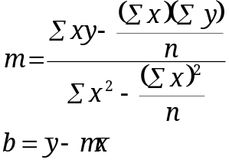

Where: 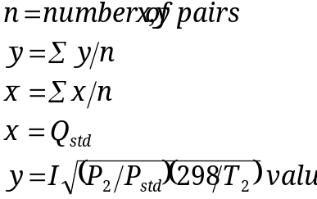

Problem Set 1, Table 5. x,y pairs for flow rate measuring device calibration curve.
x | 0.92 | 1.14 | 1.35 | 1.50 | 1.65
y | 55.1 | 43.4 | 52.7 | 58.9 | 64.0

0.92 | 35.1 | (0.92)² = 0.85 | (0.92)(35.1) = 32.29
1.14 | 43.4 | (1.14)² = 1.30 | (1.14)(43.4) = 49.48
1.35 | 52.7 | (1.35)² = 1.82 | (1.35)(52.7) = 71.15
1.50 | 58.9 | (1.50)² = 2.25 | (1.50)(58.9) = 88.35
1.65 | 64.0 | (1.65)² = 2.72 | (1.65)(64.0) = 105.6
= 6.56 | 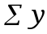= 254.1 | 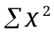= 8.94 | 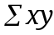= 346.9
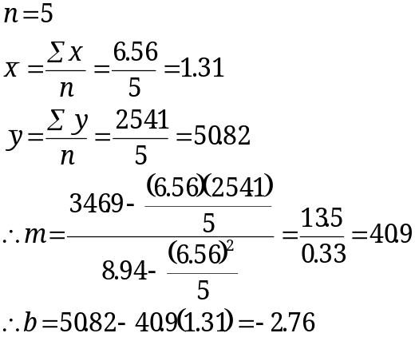

Equation of calibration curve:

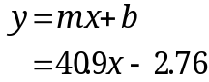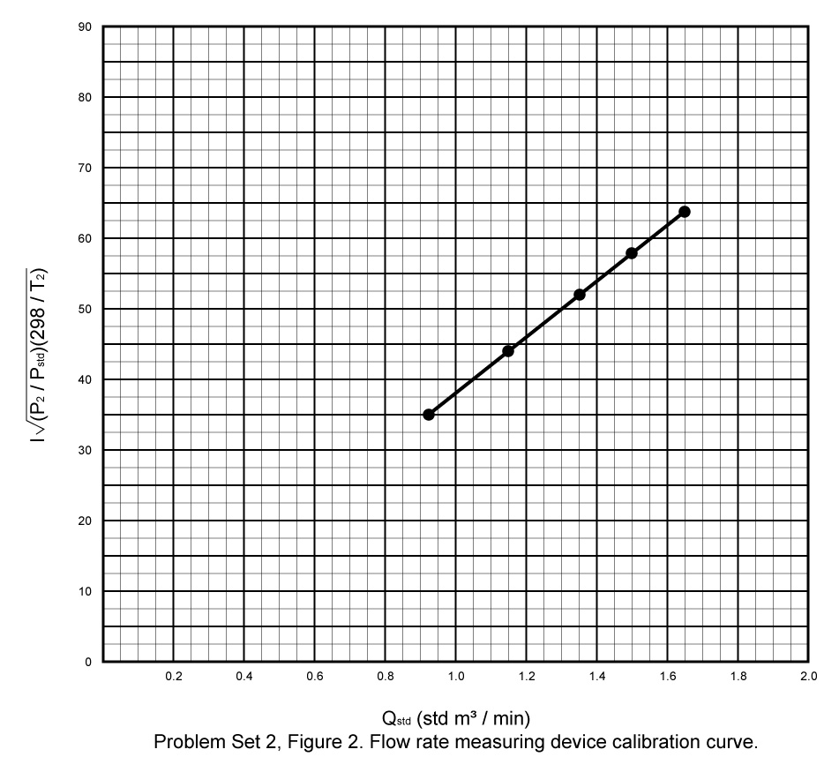
Problem Set 1, Figure 2. Flow rate measuring device calibration curve.
- The total suspended particulate matter concentration can now be determined:
- The average sampling standard flow rate must be determined by first expressing the initial and final sampling flow rate indications () with regard to the type of flow rate measuring device used and the method of correcting the sampled air volume for ambient temperature and barometric pressure using the appropriate formula from Table 6.

Problem Set 1, Table 6. Formulas for expressing indicated sampling flow rates.
Type of sampler  flow rate measuring  device | Expression
Type of sampler  flow rate measuring  device | For actual pressure (P₂) and temperature (T₃) corrections | For use when geographic average barometric pressure and seasonal average temperature  have been incorporated into  the sampler calibration
Mass flowmeter
Orifice and pressure indicator | 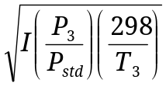 | 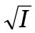
Rotameter, or orifice and pressure recorder having square root scale* | 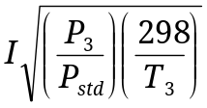
*This scale is recognizable by its nonuniform divisions and is the most commonly available for high-volume samplers.

Since the sampler’s flow rate measuring device is an orifice and pressure recorder having a square root scale and actual temperature and pressure are used to correct the sampled air volume, the initial and final sampling flow rate indications are expressed using 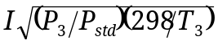:

Expressed value for initial sampling indicated flow rate:
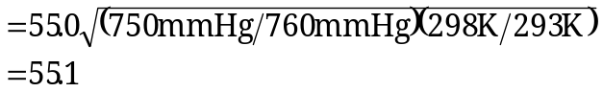

Expressed value for final sampling indicated flow rate:
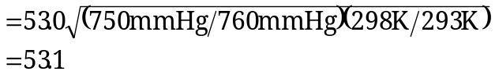

The expressed values for initial and final sampling indicated flow rates can now be used to determine the initial and final sampling flow rates at standard conditions by either referring to a graph of the flow rate measuring device’s calibration curve (Figure 2) or by calculating the sampling standard flow rates using the linear least-squares regression equation of the flow rate measuring device’s calibration curve:

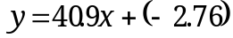

Where: 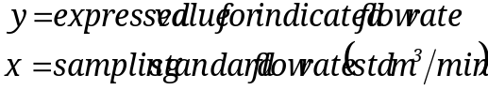

Initial sampling standard flow rate:

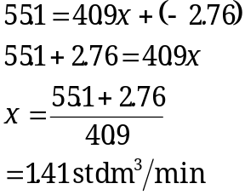

Final sampling standard flow rate:

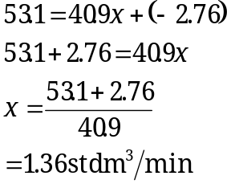

The initial and final sampling standard flow rates are then used to calculate the average sampling standard flow rate:
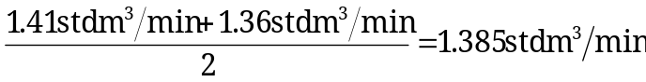

- The total sampled air volume (V) must be calculated by using the following equation:

V = (average sampling standard flow rate, std m³/min)(sampling interval, min)
=(1.385 std m³/min)(1440.0 min)
= 1994.4 std m³

- The total suspended particulate matter concentration can now be calculated by using the following equation:
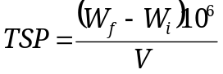
Where: TSP = total suspended particulate matter concentration, 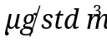
W_{i} = weight of filter before sampling, g
W_{f} = weight of filter after sampling, g
V = total sampled air volume, std m³

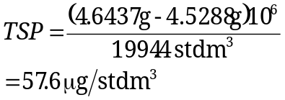

Problems
The two problems that follow are provided for the students to solve on their own. The solutions are provided after Problem 2. The students should direct any questions regarding these problems to the course instructor after reviewing the problem solutions.

- Determine the total suspended particulate matter concentration 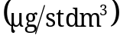 obtained using a high-volume sampler under the following conditions:

Sampling data:

Weight of filter after sampling: 4.6524 g
Weight of filter before sampling: 4.5314 g
Initial flow rate indication: 51.0
Final flow rate indication: 42.0
Sampling interval: 1440.0 min
Average ambient temperature during sampling: 30.0°C
Average barometric pressure during sampling: 711 mm Hg
Type of flow rate measuring device used: Orifice and pressure recorder having a square root scale
Method of correcting sampled air volume for
ambient temperature and barometric pressure: Actual temperature and pressure are used for each sample

Calibration data for orifice-type flow rate transfer standard that was used to calibrate the high-volume sampler’s flow rate measuring device:
Problem Set 1, Table 7. Flow rate transfer standard calibration data.
Run | Air volume measured by standard volume meter V_{m} | Time for air volume  to pass through standard volume meter  t (min) | Pressure drop at  inlet of  standard volume meter(mm Hg) | Pressure drop across orifice flow rate transfer standard  (in. H₂O)
1 | 5.66 | 5.700 | 95 | 3.00
2 | 5.66 | 4.490 | 82 | 5.00
5 | 8.50 | 5.530 | 60 | 7.90
4 | 8.50 | 4.860 | 56 | 10.20
5 | 8.50 | 4.450 | 48 | 12.70
Ambient temperature during calibration (T₁): 24.0°C.
Barometric pressure during calibration (P₁): 762 mm Hg.

Calibration data for high-volume sampler’s flow rate measuring device:

Problem Set 1, Table 8. Flow rate measuring device calibration data.
Run | Pressure drop across orifice flow rate transfer standard  (in. H₂O) | Sampler’s flow rate indication  (arbitrary units)
1 | 3.10 | 31.0
2 | 4.90 | 38.0
3 | 7.40 | 47.0
4 | 9.20 | 52.0
5 | 10.90 | 57.0
Ambient temperature during calibration (T₂): 22.0. Barometric pressure during calibration (P₂): 730 mm Hg.

- Determine the total suspended particulate matter concentration obtained using a high-volume sampler under the following conditions:
- Average sampling indicated flow rate is determined by averaging 12 two-hour indicated flow rate averages beginning at 8 a.m. from pressure recorder chart (Figure 3).
- All other conditions are the same as those for Problem 1.
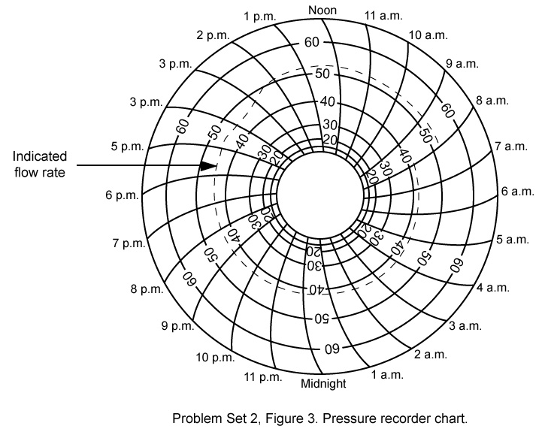
Problem Set 1, Figure 3. Pressure recorder chart.

Solution for Problem 1

- Determine calibration curve for flow rate transfer standard.
  - Correct air volumes measured by standard volume meter (V_{m}) to standard volumes (V_{std}).
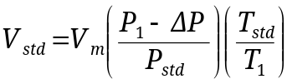
Where: T_{std} = 298 K
P_{std} = 760 mm Hg

Run | V_{m} (m³) | V_{std} (std m³)
1 | 5.66 | 4.98
2 | 5.66 | 5.08
3 | 8.50 | 7.88
4 | 8.50 | 7.92
5 | 8.50 | 8.01

  - Calculate standard flow rates (Q_{std}).

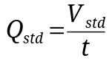

Run | V_{std} (std m³) | Q_{std} (std m³/min)
1 | 4.98 | 0.87
2 | 5.08 | 1.13
3 | 7.88 | 1.42
4 | 7.92 | 1.63
5 | 8.01 | 1.80

  - Calculate 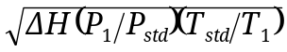 values.

Run
1 | 1.74
2 | 2.24
3 | 2.82
4 | 3.20
5 | 3.57

  - Construct graph of transfer flow rate standard calibration curve (Figure 5) or calculate linear least squares regression equation of calibration curve.

 | 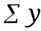 |  | 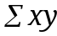
0.87 | 1.74 | 0.76 | 1.51
1.13 | 2.24 | 1.28 | 2.53
1.42 | 2.82 | 2.02 | 4.00
1.63 | 3.20 | 2.66 | 5.22
+ 1.80 | + 3.57 | + 3.24 | + 6.43
6.85 | 13.57 | 9.96 | 19.69

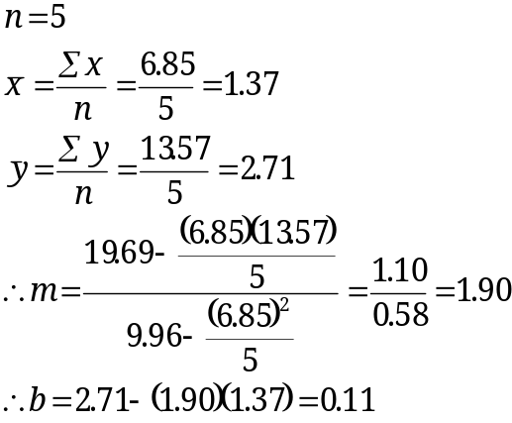

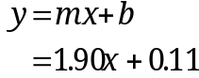
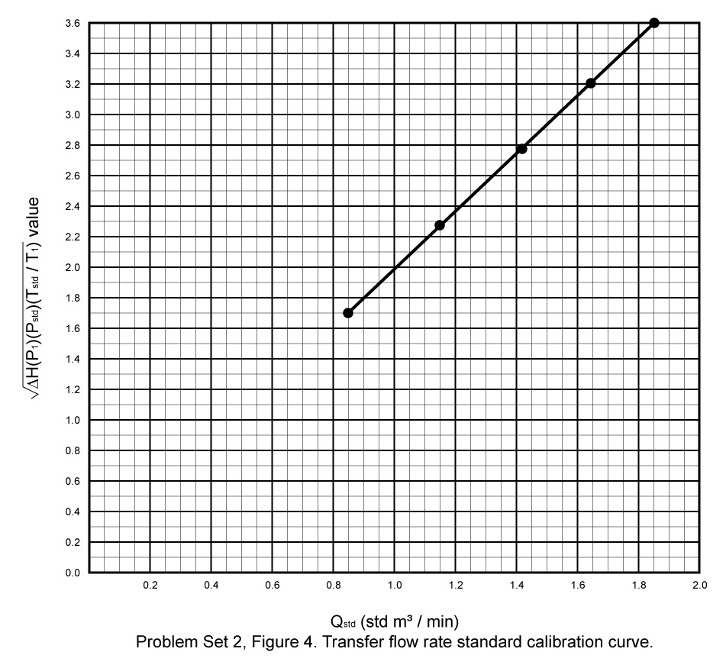

Problem Set 1, Figure 4. Transfer flow rate standard calibration curve.
- Determine calibration curve for sampler’s flow rate measuring device.
  - Calculate 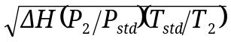 values.

Run | 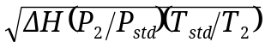
1 | 1.73
2 | 2.18
3 | 2.68
4 | 2.99
5 | 3.25

  - Determine standard flow rates (Q_{std}) by referring to a graph of the transfer flow rate standard’s calibration curve (Figure 5) or calculating the standard flow rates using the linear least-squares regression equation of the transfer flow rate standard’s calibration curve (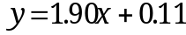).

Run | Q_{std} (std m³/min)
1 | 0.85
2 | 1.09
3 | 1.35
4 | 1.52
5 | 1.65

  - Calculate 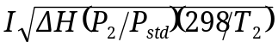.

Run
1 | 30.5
2 | 37.4
3 | 46.3
4 | 51.2
5 | 56.1

  - Construct a graph of the flow rate measuring device’s calibration curve (Figure 5) or calculate linear least-squares regression equation of calibration curve.

0.85 | 30.5 | 0.72 | 25.9
1.09 | 37.4 | 1.19 | 40.8
1.35 | 46.3 | 1.82 | 62.5
1.52 | 51.2 | 2.31 | 77.8
+ 1.65 | + 56.1 | + 2.72 | + 92.6
6.46 | 221.5 | 8.76 | 299.6

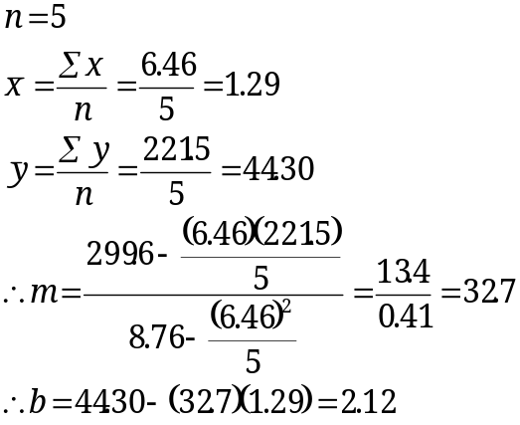

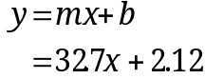
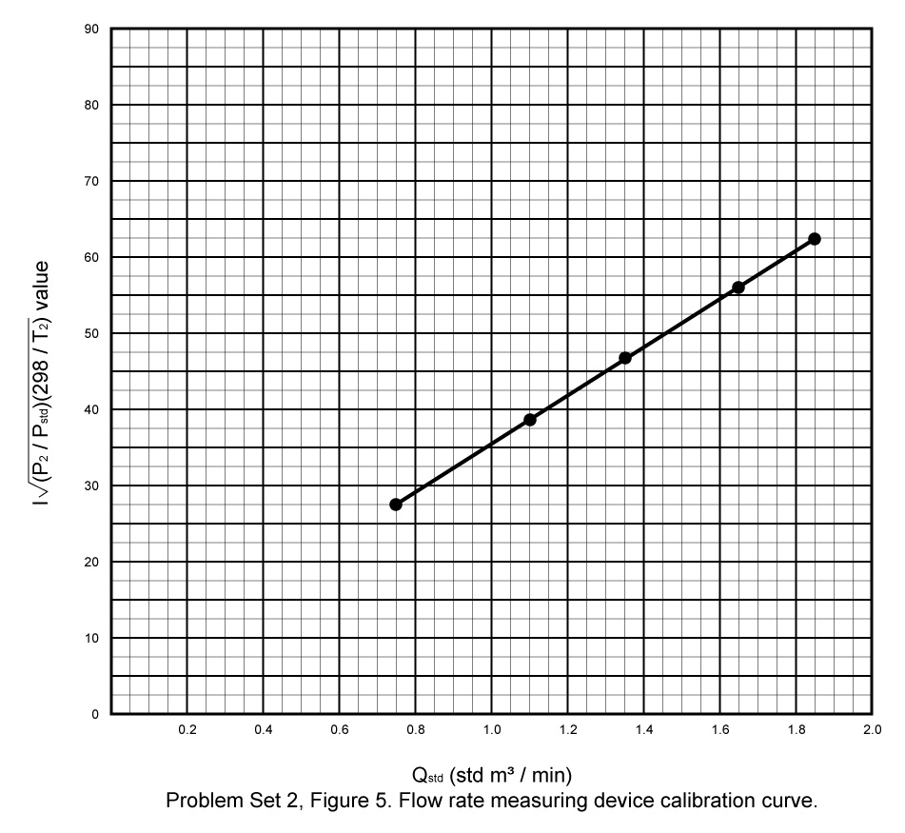

Problem Set 1, Figure 5. Flow rate measuring device calibration curve.
- Determine total suspended particulate matter concentration.
  - Calculate values for initial and final sampling flow rate indications.

Sampling flow rate indication | value
52.0 (Initial) | 49.9
42.0 (Final) | 40.3

  - Determine initial and final sampling standard flow rates by referring to a graph of the flow rate measuring device’s calibration curve (Figure 6) or calculating the sampling standard flow rates using the linear least squares regression equation of the flow rate measuring device’s calibration curve (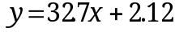).
Initial sampling standard flow rate = 1.46 std m³/min
Final sampling standard flow rate = 1.17 std m³/min

  - Calculate the average sampling standard flow rate.
  - Calculate the total sampled air volume.
  - Calculate the total suspended particulate matter concentration (TSP).

Solution for Problem 2

    - Determine two-hour indicated flow rate averages using the pressure recorder chart (Figure 3).

Two-hour interval | Average indicated flow rate (I)
8 a.m. - 10 a.m. | 52.0
10 a.m. - noon | 52.0
noon - 2 p.m. | 51.5
2 p.m. – 4 p.m. | 47.5
4 p.m. – 6 p.m. | 45.0
6 p.m. – 8 p.m. | 45.0
8 p.m. – 10 p.m. | 44.0
10 p.m. – midnight | 43.5
midnight – 2 a.m. | 43.0
2 a.m. – 4 a.m. | 42.0
4 a.m. – 6 a.m. | 42.0
6 a.m. – 8 a.m. | 42.0

    - Calculate the average sampling indicated flow rate ().

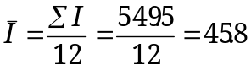

    - Calculate 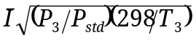 value for averaging sampling indicated flow rate ().

 | 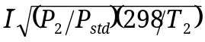value
45.8 | 43.9

    - Determine the average sampling standard flow rate by referring to a graph of the flow rate measuring device’s calibration curve (Figure 6) or calculating the average sampling standard flow rate using the linear least-squares regression equation of the flow rate measuring device’s calibration curve ().

Average sampling standard flow rate = 1.28 std m³/min

    - Calculate the total sampled air volume.

    - Calculate the total suspended particulate matter concentration (TSP).

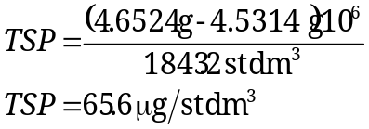

The addition of several clean filters may decrease flow beyond the normal operational range of the flow controller. Consult the operator’s manual for this operational range.

